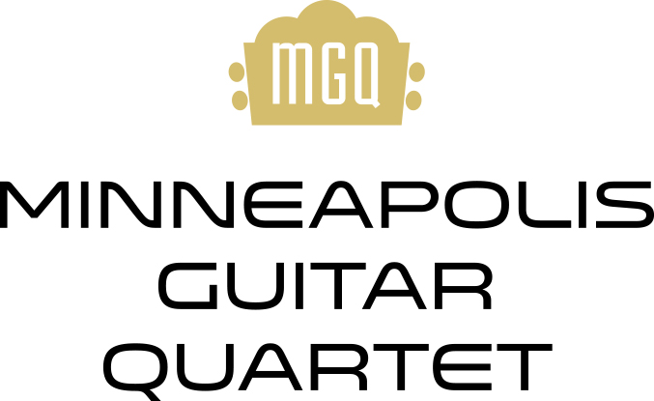

With the passion, style, and musical sophistication borrowing from the best chamber music traditions, the Minneapolis Guitar Quartet has successfully made its case as one of the world's leading guitar ensembles. "Flawless, musical and witty" (Classical Guitar Magazine), the MGQ has captivated audiences throughout the United States, Europe, and Asia. From Bach to Piazzolla to Prince, MGQ’s inventive and eclectic programs are enlivened by a bravado and synchronicity that have been honed through decades of classical training and concert experience. The Minneapolis Guitar Quartet—Joseph Hagedorn, Maja Radovanlija, Ben Kunkel and Milena Petković —builds an uncommon rapport with its audiences through its engaging stage presence and distinctive humor. “More than a guitar quartet, more than superb musicians, and more than a great chamber group,” says composer/performer Daniel Bernard Roumain. “They are ambassadors of sound, style, and substance.”

The Minneapolis Guitar Quartet’s highly varied repertoire includes their own acclaimed arrangements of music by Japanese jazz pianist Hiromi, Finnish accordionist Maria Kalaniemi, and classical composers Joaquin Rodrigo, Alberto Ginastera, and Modest Mussorgsky. From its earliest beginnings, MGQ has been dedicated to commissioning new works by living composers, from Pulitzer Prize winning composer Leslie Bassett’s Narratives (1993) to the more Balada del Bosque y el Ave by Cuban composer Leo Brouwer, and Ian Krouse’s StarWaves, based on a song by British pop/rock musician Nick Drake. MGQ’s diverse and innovative collaborations include programs for guitar quartet with choir, programs with flutist Linda Chatterton and a program with mezzo-soprano Clara Osowski. MGQ has been heard on the nationally syndicated radio program Saint Paul Sunday, and on National Public Radio’s Performance Today, and has garnered international critical acclaim from its six CDs on the Albany, GSP, and innova labels.

The cultural accessibility of the guitar makes it a natural for MGQ's various educational and community engagement programs like its popular "Guitar Talk" for all ages. MGQ's newest educational offering is its “Guitar Ensemble Crash Course”, a 90-minute class introducing participants to the "hands-on" experience of guitar ensemble playing, culminating in a live performance. All members of the Minneapolis Guitar Quartet are collegiate faculty members and frequently conduct master classes and workshops at festivals and universities throughout the United States.

For more information, please visit www.minneapolisguitarquartet.com, follow on Facebook and Twitter @MplsGuitarQt and Instagram @mplsguitarquartet
Updated February 2022

